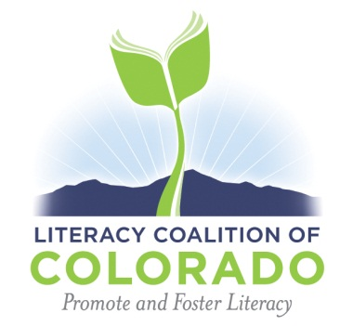

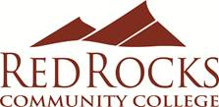

**Request for Proposals**

The Literacy Coalition of Colorado invites you to submit a workshop proposal for the annual Mini Conference hosted by Red Rocks Community College. The Mini Conference will be held Feb. 6 – 7, 2015. Sessions will run all day Friday, Feb. 6 and half-day on Saturday, Feb. 7.  Your session proposal may be accepted for both days of the conference.

The Mini Conference is attended by new as well as experienced volunteers and tutors and by experienced instructors of ESL, Family Literacy, Adult Basic Education, and GED preparation. Sessions will last one hour and fifteen minutes.

Especially desired are presentations on:

* Coaching for new tutors/volunteers
* One-on-one tutoring best practices for low level reading and writing instruction (ABE).
* Low/ Intermediate ESL instruction for one-on-one tutors (not beginning but low level)
* Beginning level ESL materials
* Finding (free) ESL materials online

Presenters are offered a $75.00 stipend and earn 10 Professional Development (PD) hours.

Please complete the attached proposal submission form and return it to Ruth Wengrovius at Red Rocks Community College – [ruth.wengrovius@rrcc.edu](mailto:ruth.wengrovius@rrcc.edu)

The deadline for submissions is January 9, 2015.

Thank you for sharing your experience and skills with your colleagues!